1)<script>
let me="Hello World";
alert(me);
</script>



2) <script>
const num=2;
let str="Vish";
let BigInt=1223456789n;
let u;
console.log(num);
console.log(str);
console.log(BigInt);
console.log(typeof num);
console.log(typeof str);
console.log(typeof BigInt);
console.log(typeof u);
</script>
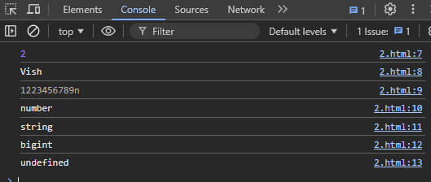
4) <script>
var first="Vishnu";
var second="Priya";
document.write(first+second);
<script>


3) <script>
var a=20;
var b=100;
console.log(a+b);
console.log(b-a);
console.log(b/a);
console.log(a*b);
</script>



5) <script>
var b;
const c=null;
let name = {
age: 30,
};
let rno = Symbol("rollno");
name[rno] = 62;

let num = 1300;

document.write("Type of rno: " + typeof rno + "<br>");
document.write("Type of name: " + typeof name + "<br>");
document.write("Type of num: " + typeof num + "<br>");
document.write("Type of b: " + typeof b + "<br>");
document.write("Type of c: " + typeof c + "<br>");
</script>
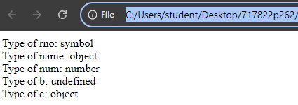

6) <script>
//This is the example of single line comment.
document.write("Hello");
/*hello heloooo
This is multiline
comment's example*/
</script>
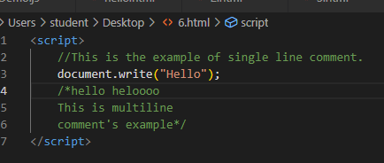

7) With semi colon: Without semi colon:

<script >
document.write("Hello"+"<br>");
document.write("I am a college student"+"<br>");
document.write("in this college"+"<br>");
</script>

<script >
document.write("Hello"+"<br>");
document.write("I am a college student"+"<br>");
document.write("in this college"+"<br>");
</script>



No difference in the output!!!

9)
<script>
let a,b,c,d;
a=10;b=20;c=30;d=40;
document.write(a+b+c+d);
</script>



8)
<script>
let rows = 5;
let columns = 5;
for (let i = 1; i <= rows; i++) {
for (let j = 1; j <= columns; j++) {
document.write((i * j) + "\t");
}
document.write("<br>");
}
</script>

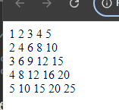

10) Scripts can modify HTML elements, so placing the <script> tag at the bottom of the <body> ensures that HTML elements have fully loaded, reducing the risk of modifying elements causing errors

